**LAB Manual 17**

**Rider**

* Make different kind of surfaces
* Make a collider

1. Go to Assets Store
   * Download Post Processing Stack
   * Import all assets

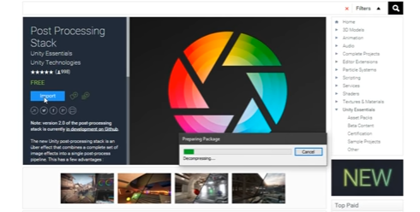

After adding/importing post processing stack

1. Select main camera and change the projection size to 7 to zoom out
2. Add component to main camera: post processing behavior through search

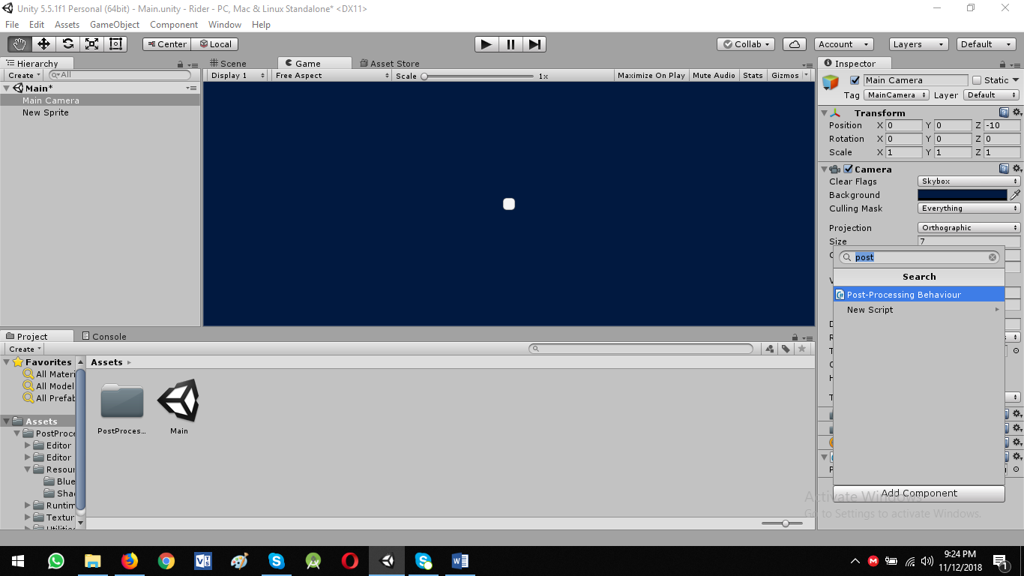

* Create a profile for color collection : Project View -> Create -> post processing profile
  + Required for color collecting settings

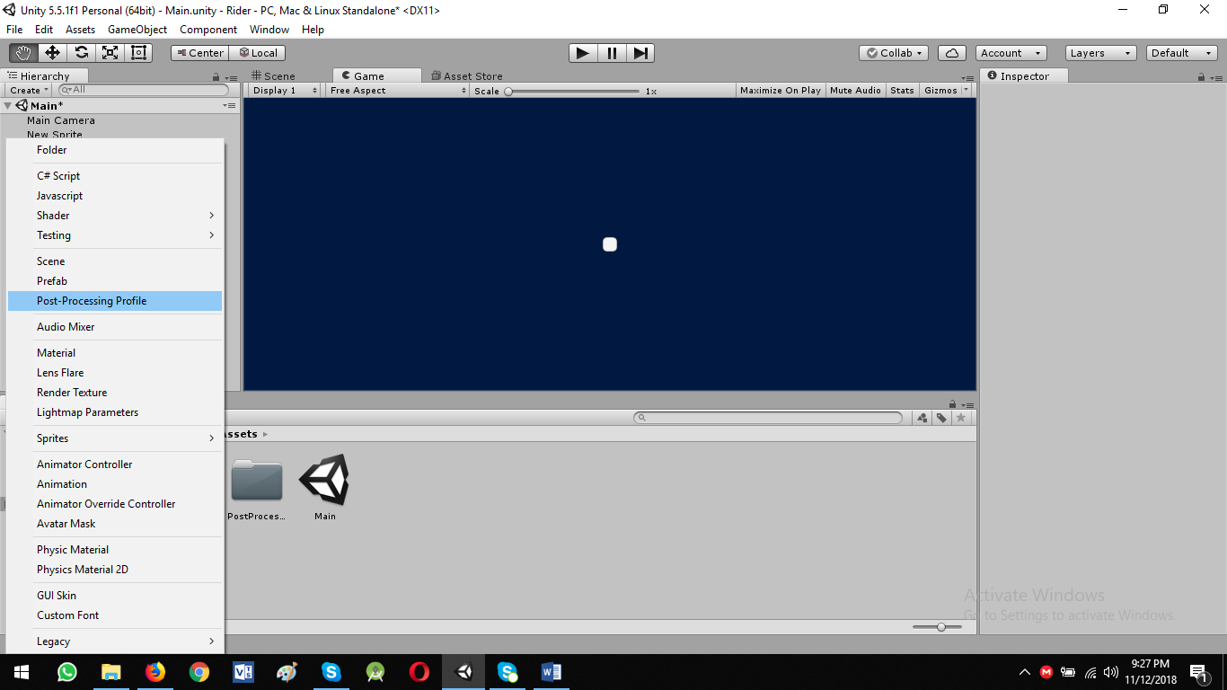

* Rename it to CC
* Select Main Camera and drag the CC object

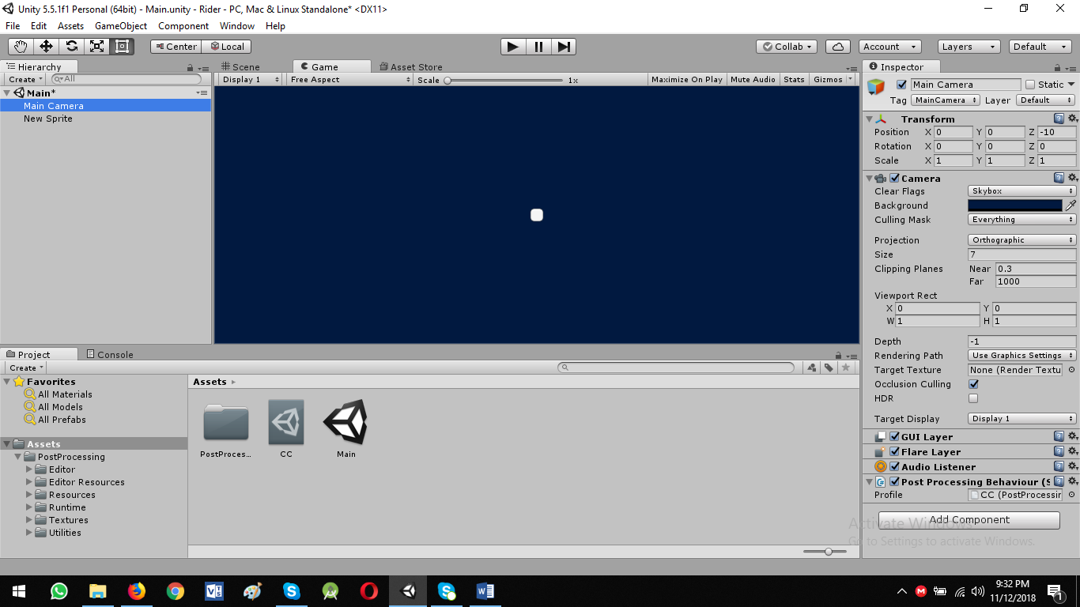

* Now click on CC object and select
  + Vignette -> Intensity : 0.2
  + Color Grading -> Filmic & Post Exposure: 0.5
* Select the main camera and light the background color

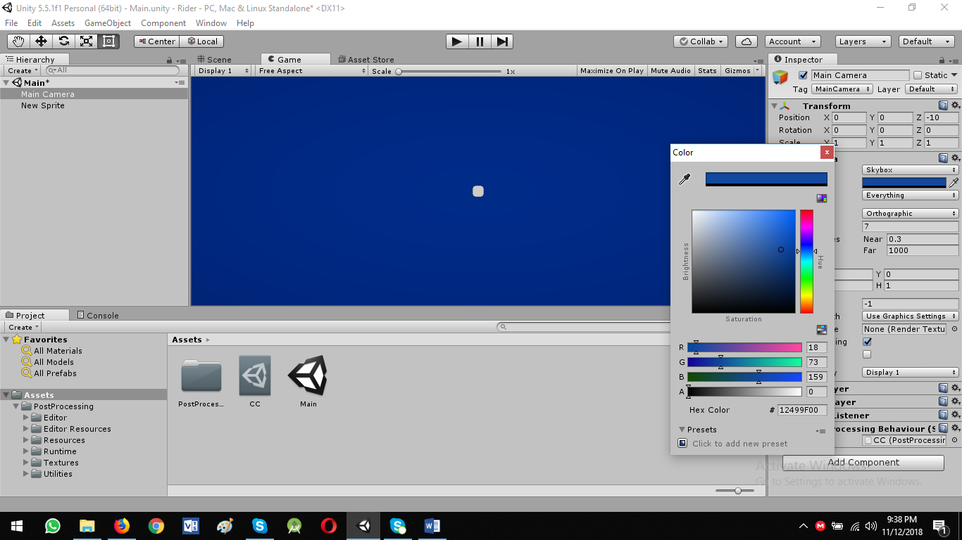

* From CC

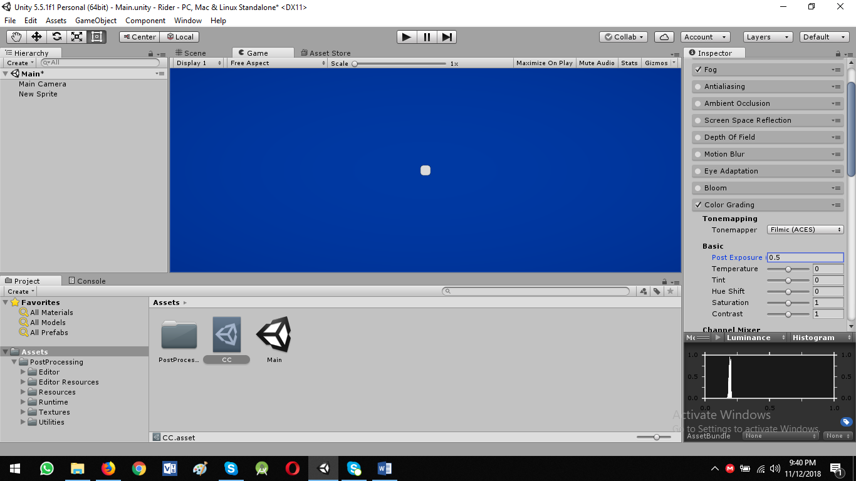

* Now add the motion blur: Shutter Angel to 230
* Delete the tiny Sprite

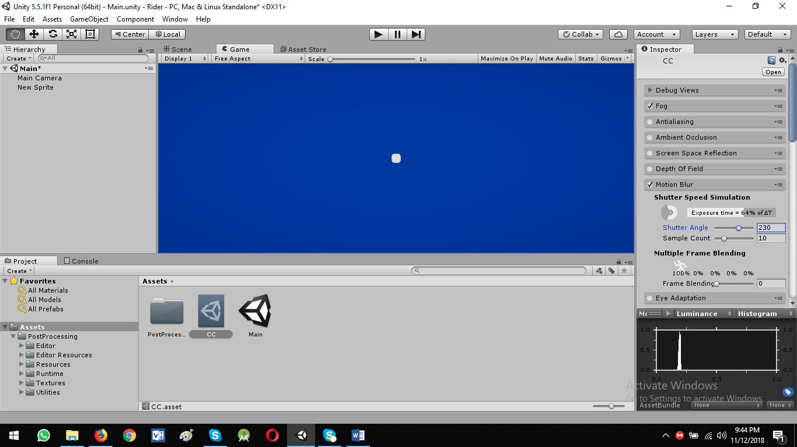

Error in Script: UnityEngine.LineRenderer' does not contain a definition for `positionCount'

Solution:

public int numPositions;

<https://docs.unity3d.com/550/Documentation/ScriptReference/LineRenderer-numPositions.html>

**Now go ahead**

* Create an empty object in Hierarchy view
  + Right click and create empty
  + Rename it to LineSegment

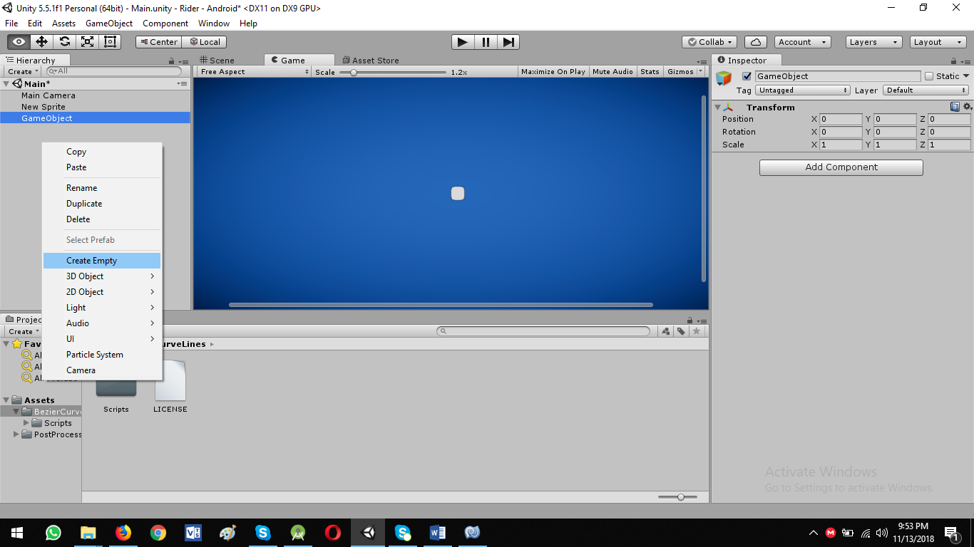

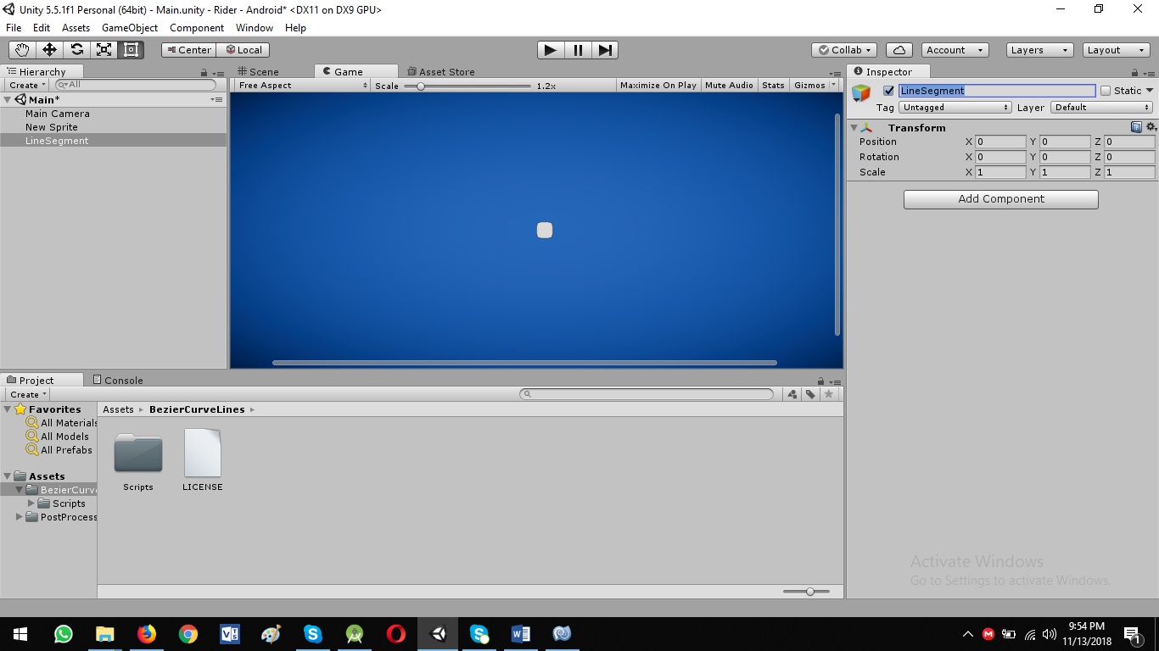

* Add component -> Physics 2D ->Bezier Curve Collider 2D

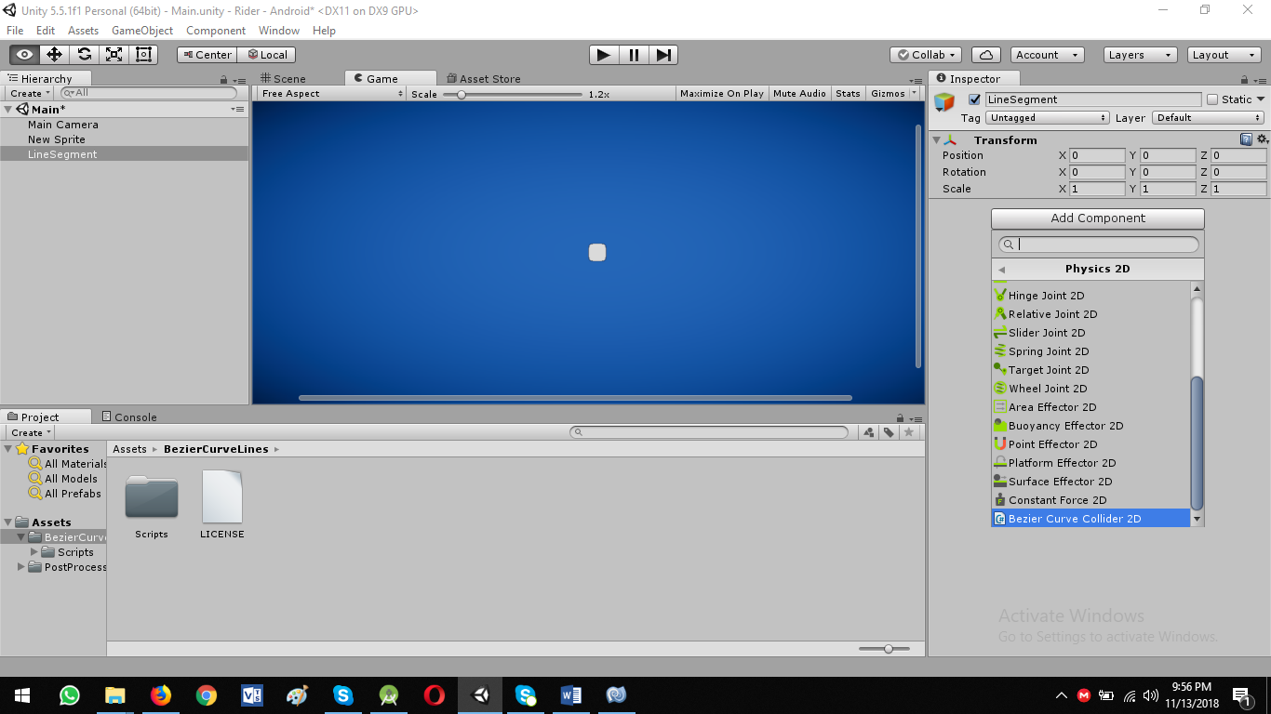

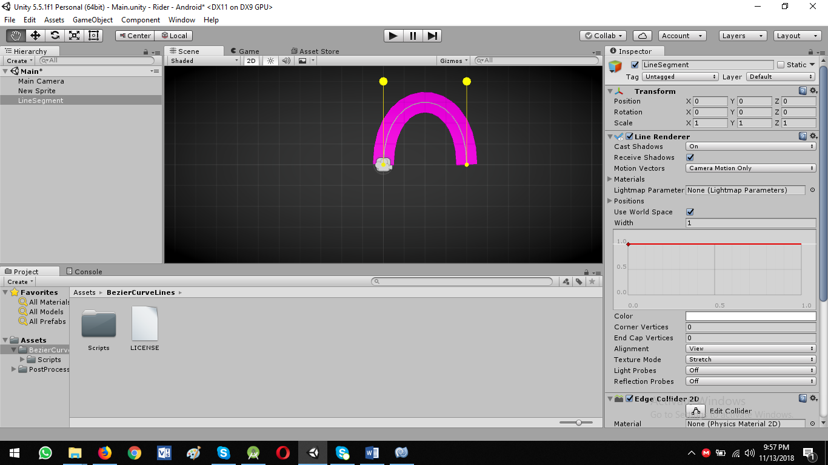

* Collider is inside the fancy curve line
* You can edit in editor
* Now insert add point

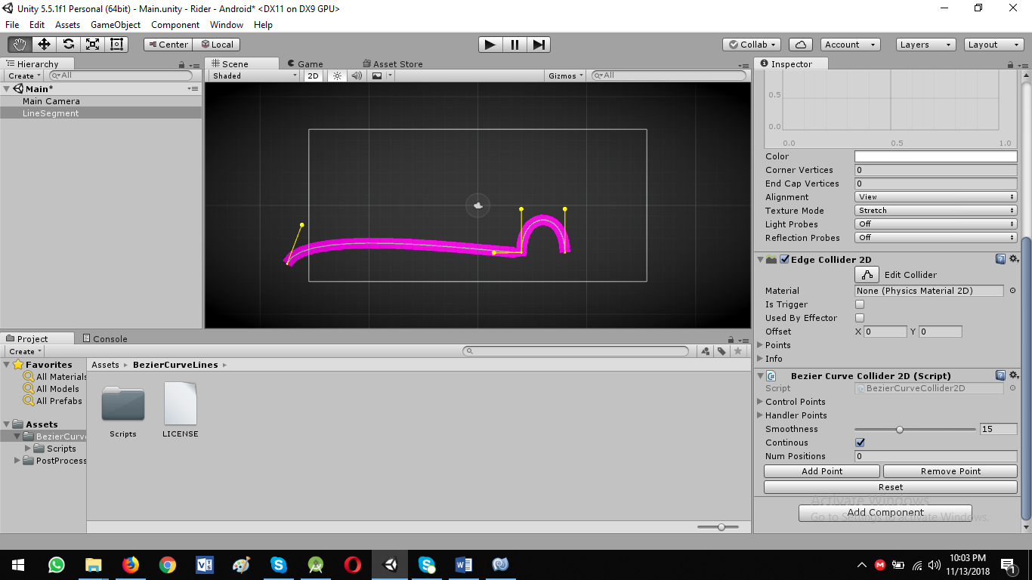

* Add new points

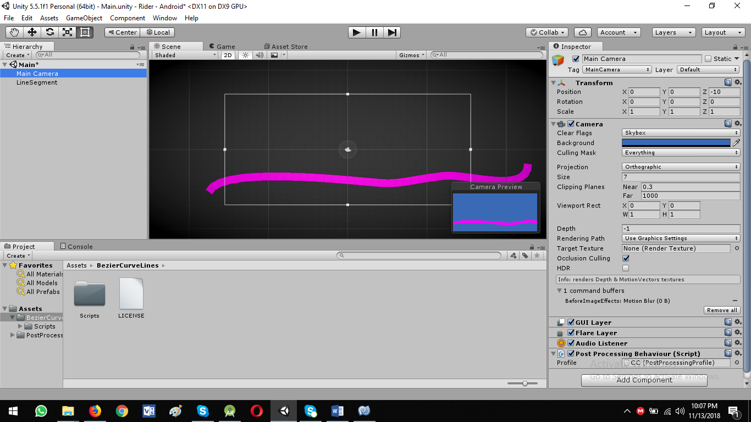

* You can see preview in Game View
* Change smoothness value: Around value 20 is fine

Now go to Line Renderer Option

* Change width to 0.15
* Smooth the ending of lines
* Enter 3 to **End Cap Vertices**

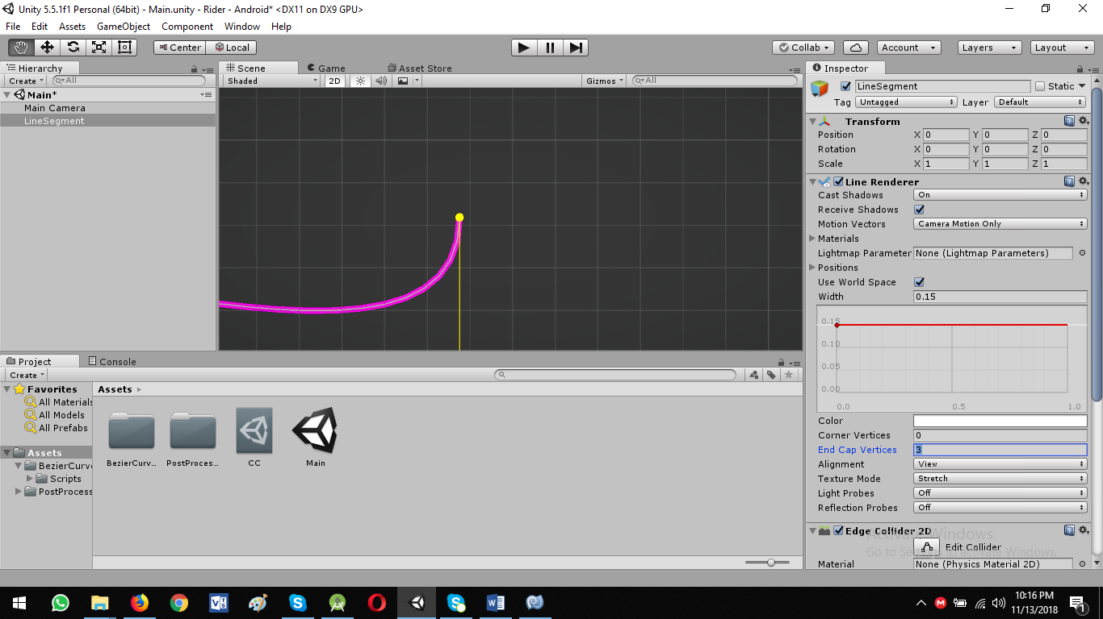

Now add custom material to our line

* Project Panel -> Right Click -> Material -> Rename it: LinePurple

We want to add glowing in our line: Let’s add new custom extension MK Glow Free

<https://assetstore.unity.com/packages/vfx/shaders/fullscreen-camera-effects/mk-glow-free-28044?aid=1101lPGj&utm_source=aff>